THE MANUSCRIPT TITLE WRITTEN IN ENGLISH, UPPER CASE LETTER
First A. Author¹, Second B. Author² and Third C. Author³
¹ First author’s affiliation
² Second author’s affiliation
³ Third author’s affiliation
KEYWORDS |  | ABSTRACT
about 5 to 10 words, splited the line into a list of words, in English, Sentence case, Italic |  | The abstract should be about 150 to 300 words in length and in lower case letters. The abstract should state concisely the whole research work including the necessary, purpose, methodology and main results obtained, not just the conclusions. It should contain no citation to other published work and uncommon abbreviations.

1. Introduction

The introduction should provide Readers with the background information needed to understand the study topic, specify the limitation of previous research works, identify reasons to conduct this work and contribution on theory and application, present the research objectives, methodologies, means of study and main results obtained.
The manuscript is written by Microsoft Word with about 15 to 18 pages long in A4 (21 x 29.7 cm), font type: Times New Roman, font size: 13, line spacing: multipal at 1.2, space before paragraph: 6pt and all margins (top, bottom, left and right): 2.5 cm.
The manuscript should contain sufficient detail and references to permit others to replicate the work. A number of relevant references should be cited in the introduction and other sections, approximately 20 to 30 references. The cited references should be strongly related to the research question.
References are numbered in order of their appearance and enclosed in square brackets, for example [1-3] or [1, 2, 5]. The references listed at the end of the manuscript should all be cited in the manuscript and vice versa; the references cited in the manuscript should be listed in the references.

2. Section title written in a specific and concise manner to represent the section content, in lower case and bold letters
A manuscript usually has several sections and numbered in the order of 1., 2., 3., etc., i.e. 1. Introduction, 2. Section title, 3. Section title, 4. Section title and 5. Conclusions. Any too long section should be divided into two or more sub-sections and numbered in the order of such as 2.1., 2.2., 2.3.,...
The section and sub-section titles should be written in a specific and concise manner, containing information related to the section content, avoiding too short or too long, too general or too detailed section titles.
2.1. Sub-section title in lower case letters, italic:
Figures and photos should be clear, not blurred; use Times New Roman font type, in lower case letter; include relevant captions and notes placed below the figures and photos, in lower case letter, centered; numbered and cited in the text (Figure 1).
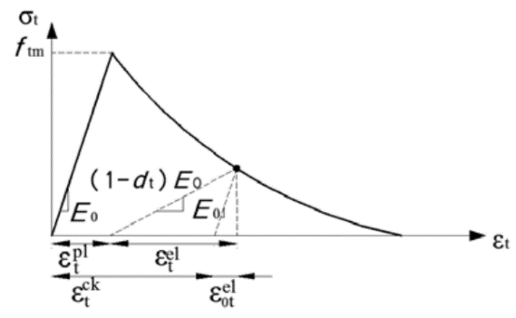
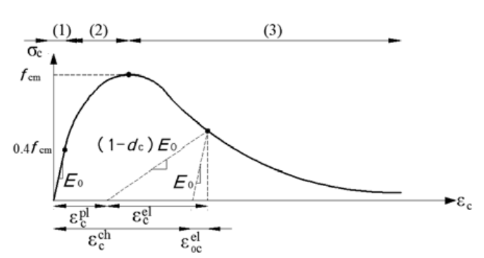

(a) Compression (b) Tension

Figure 1. Assumed uniaxial model of concrete behavior

Tables should be formatted clearly and uniformly; use Times New Roman font type, in lower case letter; include titles placed above the tables, in lower case letter, centered; numbered and cited in the text (Table 1).
Table 1. Seismic weights and static loads acting on frames
No. | H-2-32-200 |  |  | S-2-32-200
 | W_{i} (kN) | s_{i} | F_{i} (kN) | W_{i} (kN) | s_{i} | F_{i} (kN)
1  2  3 | 19.77  54.57  174.97 | 0.00377  0.00439  0.00024 | 3.09  9.91  17.60 | 20.74  54.77  167.40 | 0.00428  0.00369  0.00249 | 6.29  14.32  29.56

2.2. Sub-section title in lower case letters, italic:
Equations should be typed clearly using the MathType in Microsoft Office Word; numbered in order and within parenthesis (…) on the right-hand side of the equation; cited in the text (Eq. 1).
when (1)
where T is the fundamental vibration period of the structure (sec.), a_{g} is the maximum design ground acceleration on the ground type A (m/s²), S is the ground type factor, T_{B} is the spectral acceleration (sec.) and q is the structural behavior factor [1].
Units should be the international system of units (SI), i.e. kN, N for forces and m, cm, mm for lengths.
3. Section title written in a specific and concise manner to represent the section content, in lower case and bold letters
3.1. Sub-section title in lower case letters, italic:
3.1.1. Title in lower case letters.

3.1.2. Title in lower case letters.

3.2. Sub-section title in lower case letters, italic:

4. Conclusions
The conclusions should concisely be supported by the main results achieved in the study, avoiding overstatement of the importance of the findings. The conclusions should be consistent with the research objectives and within the scope of the study which are stated in the introduction. Limitations of the study may also be noted in the conclusions.

References
References should be listed at the end of the manuscript, numbered according to the order of appearance in the text, cited in the text in square brackets […] and vice versa; ensure the following IEEE format:
- For books:
[No.] Author’s name, Title of book, edition (if not first). Place of publication: Publisher, Year
- For Chapters in books:
[No.] Author(s) of chapter, “Title of chapter”, In Title of book, edition (if not first), Editor(s) of book, Ed. Place of publication: Publisher, Year, Page number(s).
- For conference articles:
[No.] Author(s) of paper, “Title of paper,” Title of conference’s proceeding, palce of organization, time of organization – italicized, Place of Publication: Publisher, year of publication, page numbers.
- For scientific journal articles:
[No.] Author(s) of paper, “Title of paper,” Journal name- italicised, volume number, issue number, page number(s), year. DOI: xx.xxxxxxxxxx (if available)
- For magazine articles:
[No.] Author(s) of article, “Title of article,” Title of newspaper – italicised (Year of publication, month day), page number(s).

- For PhD dissertations, Masters’ theses:
[No.] Author, “Title of thesis – italicised,” Doctoral dissertation/Master's thesis, Institution, Location, year of preparation of thesis.
- For Internet addresses:
[No.] Author(s) of document, “Title of document,” Time document created or revised. [Online]. Availabe: http://www...... [Accessed mm dd yyyy].

